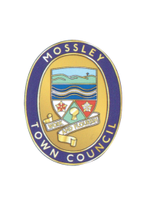
Mossley Town Council
Annual Parish Meeting

Please note that current social distancing requirements must, at all times, be adhered to when attending the meeting.

All attendees must wear a face covering prior to and throughout attendance at the meeting.

YOU ARE HEREBY INVITED to attend the PARISH MEETING of the Mossley Town Council to be held on Wednesday 19 May 2021 at Mossley Methodist Church Hall, Chapel Street at 8.00pm at which the following business will be transacted.

AGENDA

1 | Minutes of the Parish Meeting held on 29 May 2019  To approve as a correct record and sign the minutes of the Parish Meeting held on Wednesday 29 May 2019 (Enclosed)
2 | Review of activities of Mossley Town Council 2019/2021  Parish Council Chair and Clerk to report
3 | Public Questions  Members of the public present at the meeting are invited to ask questions about the work of the Parish Council or any issues pertaining to the Parish.
3 | To consider proposals for activities for Mossley Town Council for 2021/2022.  Members of the Public are encouraged to put forward ideas for action during the next financial year.
4 | Mossley Neighbourhood Plan - Initial Arrangements for Consultation  To invite interested parties to a first stage meeting to invite comment and suggestions on the Draft Consultation Strategy.
 | Mike Iveson  Clerk to the Council  12 May 2021 |  | Tel: 07809 690890  Email: the clerk @mossley-council.co.uk

