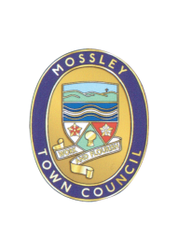
Mossley Annual Parish (Town) Meeting

MOSSLEY RESIDENTS are HEREBY INVITED to attend the Mossley Annual Parish (Town) Meeting to be held on:

Wednesday 11 May 2022

at Mossley Methodist Church Hall, Chapel Street

at 8.15pm

AGENDA

1 | Minutes of the Parish Meeting held on 19 May 2021  To approve as a correct record and sign the minutes of the Annual Parish (Town) Meeting held on Wednesday 19 May 2021 (Enclosed)
2 | Review of activities of Mossley Town Council 2021/2022  Parish Council Chair and Clerk to report
3 | Public Questions  Members of the public present at the meeting are invited to ask questions about the work of the Parish Council or any issues pertaining to the Parish.
4 | Development in Mossley  Development sites in Mossley  This item has been included on the agenda at the request of local residents who wish to address the Town Council on potential development sites in the Town.
5 | To consider proposals for activities for Mossley Town Council for 2022/2023.  Members of the Public are encouraged to put forward ideas for action during the next financial year.
 | Mike Iveson  Clerk to the Council |  | 4 May 2022  Tel: 07809 690890  Email: theclerk@mossley-council.co.uk

