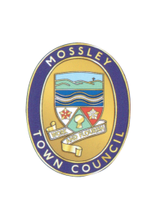
Mossley Annual Town Meeting

MOSSLEY RESIDENTS are HEREBY INVITED to attend the Mossley Annual Town Meeting to be held on:

Wednesday 10 May 2023

at Mossley Methodist Church Hall, Chapel Street

at 8.15pm

AGENDA

1 | Minutes of the Parish Meeting held on 11 May 2022  To approve as a correct record and sign the minutes of the Annual Town Meeting held on Wednesday 11 May 2022 (Enclosed)
2 | Review of activities of Mossley Town Council 2022/2023  Parish Council Chair and Clerk to report.
3 | Public Questions  Members of the public present at the meeting are invited to ask questions about the work of the Parish Council or any issues pertaining to the Parish.
4 | To consider proposals for activities for Mossley Town Council for 2023/2024.  Members of the Public are encouraged to put forward ideas for action during the next financial year.
Mike Iveson
Clerk to the Council

3 May 2023

Tel: 07809 690890

Email: theclerk@mossley-council.co.uk

