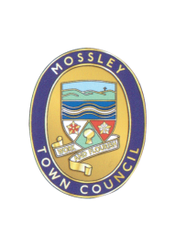
Mossley Annual Town Meeting

MOSSLEY RESIDENTS are HEREBY INVITED to attend the Mossley Annual Town Meeting to be held on:

Wednesday 15 May 2024

at Mossley Methodist Church Hall, Chapel Street

at 8.30pm

AGENDA

1 | Minutes of the Parish Meeting held on 10 May 2023  To approve as a correct record and sign the minutes of the Annual Town Meeting held on Wednesday 10 May 2023 (Enclosed)
2 | Review of activities of Mossley Town Council 2023/2024  Town Council Chair and Clerk to report.
3 | Public Questions  Members of the public present at the meeting are invited to ask questions about the work of the Parish Council or any issues pertaining to the Parish.
4 | To consider proposals for activities for Mossley Town Council for 2024/2025.  Members of the Public are encouraged to put forward ideas for action during the next financial year.
Mike Iveson
Clerk to the Council

8 May 2024

Tel: 07809 690890

Email: theclerk@mossley-council.co.uk

